Was Peter Parley Disabled?

Stephen Krewson

Table of Contents

## Note

*This is the beginning of a chapter, probably my second. Each chapter in my dissertation tells the story of a key figure within early-19C “practical” education. As I work through the primary texts, I engage each figure with a contemporaneous problem within education and an object ("apparatus") or image ("cut") that speaks to that problem. Thus, the preceding chapter (which follows a more theoretical introduction) tells the story of Josiah Holbrook, creator of the lyceum movement. Holbrook's obsession with manufacturing globes for children led him to eventually task children with the manufacture of globes. This one sketches the prehistory of Samuel Goodrich’s Peter Parley character. The problematic concerns “special education” and the image we will focus on is that of Parley himself, as it variously depicts his physical disability.*

## Introduction

The most popular children’s book character in nineteenth-century America, Samuel Griswold Goodrich’s Peter Parley, was birthed by the rise of new forms of geographical education in the 1820s. Illustrated didactic works like William Channing Woodbridge’s *Rudiments of Geography* (1821), the intellectual and visual basis for the first Parley book, *Tales about America* (1826), had in turn been shaped by the encounter between a class of progressive educator-authors and students with disability. Karen Bourrier has brought to light the sheer number of healthy-invalid character dyads in the mid-century novel. (Bourrier) By strategically collating key texts within the mass of educational editions put out by Goodrich and his peers, we can antetade Bourrier's finding that Victorian authors innovated a point of view that was focalized through the disabled male body.[1] A quarter-century earlier, we find that the Parley books and periodicals are structured by their narrator’s physical impairments. So much so that young readers even complained at inconsistent representation of those impairments. The appeal of the disabled adult narrator within juvenile literature is evidenced by its adoption by Jacob Abbott (creator of the Rollo series) among other authors. While the disability of these narrators solves the initial plot problem of why a group of children should feel safe in attending to an adult stranger, its currency in the early-19C is more fully understood through an analysis of how Pestalozzian sense education was received in the United States, reworked at institutions such as the Connecticut Asylum for Deaf and Dumb Persons and the Perkins School for the Blind, and contested within a print ecosystem in which there was intense competitive pressure to produce (or recycle) text and image.

Lines of influence between educational theory and media format ran in both directions: the “kinesthetic” mode of education was useful for publishers in the advertisement of illustrated juvenile texts. At the same time, the saturation of the educational market with generic illustrated “concoctions” meant an impoverishing of the full Pestalozzian program, with its emphasis on outdoor, embodied learning supplemented by graduated apparatus kits. By the mid-1830s, Goodrich and his stand-ins Parley and Robert Merry were soliciting a modified form of perceptual attention: through the absorbed “reading” of whatever woodblocks were at hand, they hoped to construct in print a “circle” of imaginative young interpreters. The requirements for belonging to this circle were eyesight and enough literacy to write a short letter to the editor. The various incarnations of Peter Parley are a measure of the gap between this virtualized collective perceiving and the situated scientific fieldwork imagined by the practical educationists. To tell Parley’s prehistory is thus to tell his afterlife. The smash-up of idealizing school reform movements with the reality of disability and the allure and limitations of print gave him his animating force and motivated his several resurrections.

My “method of telling” this story, to use a Goodrich turn of phrase, will be to look closely at the objects and images that the reader is instructed to attend to in texts written by the authors and narrators above. To move beyond my subjects’ explicit theories of perception and collective learning, I will look—sometimes closely, sometimes distantly—at a range of “cuts” through which the implicit knowledge systems and subjecthood norms of Parley’s world become visible. My through-line will be the image of Parley surrounded by children. Goodrich was a practitioner par excellence of reuse, “remodeling”, “projection,” and “blocking”: each time he commissioned or acquired images, he was dipping into a large but finite pool of semantic possibility. Nor was the meaning of a cut fixed from the date of its creation onward; the sanding down of distasteful areas in certain blocks used in *Parley’s Magazine* suggests that the engraver’s burr, compositor’s stick, and editor’s pen were linked in navigating the politics of representation. Thus we can answer the question: Peter Parley was disabled because his creator was disabled and because the limit cases of deaf and blind children shaped progressive education. Disability was a useful “illustration” of how to deal with adversity. The other kind of “illustration,” the graphic kind, was unevenly suited for the sight disabled. At least in the kind of public, absorbed attention that Parley and his editor-successors want.

## "He ain't Peter Parley"

The reason Samuel Goodrich could not possibly be Peter Parley, according to the young boy in Savannah, was that "he hasn't got his foot bound up, and he don't walk with a crutch!" So keen was the boy's dismay that he told his grandfather he wouldn't have "any thing to do with" Goodrich. (Goodrich 323) This anecdote features in Letter 50 of the *Recollections*, in which Goodrich tours the South. The trip culminated in a public reception in New Orleans in March of 1846 at which the author and "friend of education" was toasted by the leading lights of the city's lyceum. Domestic travel presented Goodrich, then 52, with first-hand evidence of his character's popularity. Both adults and children welcomed him "under the name of the fictitious hero whom I had made to tell my stories." As the lyceum president put it: "Mr. Goodrich, or, as we all love to call you, Peter Parley..." (324) The lyceum speechifying documented in the letter traffics in the old ideas of character as a way for authors to inculcate good morals and live on after death. But Goodrich hints at a more complex authorial situation when he admits that, at times, he "underwent rather sharp cross-questioning":

I, who had undertaken to teach truth, was forced to confess that fiction lay at the foundation of my scheme! My innocent young readers, however, did not suspect me: they had taken all I had said as positively true, and I was of course Peter Parley himself. (322)

Goodrich dramatizes a scene of interrogation in Mobile, Alabama, in which he owned up to an eight-year-old girl that he has not, in fact, been in prison in Africa or even in Africa at all.

The eight-year-old's quiz about the reliability of *Tales about Africa* and the young boy's aversion to the crutchless Goodrich represent two different kinds of truth-seeking behavior, conditioned by age.[2] On one view, widely represented in the scholarship on children's literature, growing out of the "innocent young reader" stage means learning to take pleasure in one's ability to switch between the fictional and the real, not in fantasy itself. But the juxtaposed reactions of Goodrich's southern readers point to a different economy of character, one in which consistency and availability rather than a bright line dviding truth from fiction are paramount.[3] Because Goodrich writes in the "useful and entertaining knowledge" genre, the plausibility of his travel writing depends in large part upon how he manages that genre's norms of textual compilation and reuse. A first-person serialized narrator like Parley presents certain difficulties. An editor, either silently or through a spectator-collector persona, could straightforwardly compile from a range of natural-historical dispatches. But making one character responsible for *all* the facts and adventures in a globetrotting series pushed beyond the limits of plausibility. As a result, the facts might come to be seen in a less factual light. Goodrich, "who had undertaken to teach truth," feels this tension when he speaks to his "young friends" in person.

On the one hand a genre problem: how to incorporate a frame character into "penny magazine"-style prose without undercutting the text's payload of "useful" (even if sensationalized) facts? On the other, a visual inconsistency between an author and his creation. This latter problem has as much to do with techniques of celebrity and capitalist advertising as with literary form. But insofar as both problems are about validity, the figure of the *invalid* provides a way to connect them. The story of how Parley became disabled starts with the story of how Goodrich's personality became sutured to Parley in the first place. Disability hastened their coextension. The inaugural Parley book, the sextodecimo *Tales about America* (1827), had been published anonymously. Goodrich recollects in Letter 47 that he divulged his authorship only to his wife and sister because of literary shyness and the fact that "nursery literature had not then acquired the respect in the eyes of the world it now enjoys." (279) Soon enough, though, the word got out. Certainly by 1832, when Goodrich was already drafting up Parley licensing deals to stem the flow of pirated British editions.[4]

Parley caused Goodrich "endless vexations" in relation to copyright; but in a quite literal sense he almost killed him upon arrival. In the four years following *Tales about America*, Goodrich worked 14-hour days, dictating to his wife on account of his strained eyesight. In the spring of 1832, he experienced a nervous breakdown and suffered heart palpitations worrying enough to send him off to Europe to convalesce. Compare the initial depiction of Parley in 1827 with those in 1830 and 1831. The 1827 wood engraving (unsigned, but likely done by a Boston workshop) depicts an older gentlemen with a walking stick. The visual emphasis is on *walking*, since Parley is striding away from what is likely the Massachusetts State House at the top right of the vignette.[5] The later Parleys are no longer anchored to their home city of Boston but are domestically laid up in chairs, with bandaged right feet. The walking stick has morphed into a crutch, with its distinct underarm support. Goodrich declines to "weary" the reader with the details of this "busy and absorbed period" of his life (280). But the shock of Parley, in terms of the character's unexpected commercial success and the ensuing incitement to overwork, registers iconographically in a walking disability. The quickness of this physical decline is humorously embedded in the frontispiece wood engraving to the *Method of Telling about Geography*: Parley reclines grumpily by the hearth, warding off the approach of seven children. Above him on the wall? A large framed portait of the 1827 Parley, walking confidently away from the state house and onto the Boston Common.[6]

The perambulating Parley and the bum leg Parley were each memorable in their own way. Stephen Dedalus remembers the former in *Portrait of the Artist*:

History was all about those men and what they did and that was what Peter Parley's Tales about Greece and Rome were all about. Peter Parley himself was on the first page in a picture. There was a road over a heath with grass at the side and little bushes: and Peter Parley had a broad hat like a Protestant minister and a big stick and he was walking fast along the road to Greece and Rome.

Joyce's source for this reference, which comes at the critical juncture where Stephen is summoning the courage to appeal to Father X about his unfair beating at school, was likely a late-1890s Glaswegian edition of Parley's Greek and Roman tales, which first appeared in the United States "as historical compends" in 1832-33.[7] Cross-Atlantic differences in Parley iconography, and the whole question of Parley's socio-political footing (Protestant, Whig, and so forth) merit future discussion. The point for now is that Joyce's source is based on the 1827 Parley cut, with its road winding over the heath and through the small shrubs. The outcome of a young reader's (or young, researching author's) encounter with Parley was contingent on the editions available in their historical time and place: either the fast-walking or the lame Parley might end up being stickier, the stuff of adult nostalgia or free indirect musing. Writing from France in the 1850s, however, Goodrich

The little book entitled "*Parley's Method of Telling about Geography to Children*," had a picture, drawn by Tisdale, representing Parley sitting in a chair, with his lame foot bound up, and a crutch at his side, while he is saying to the boys around--"Take care, don't touch my gouty toe; if you do, I won't tell you any more stories!" Of this work two millions were sold, and of course Parley and his crutch were pretty generally associated together, in the minds of children. (323-324n.)

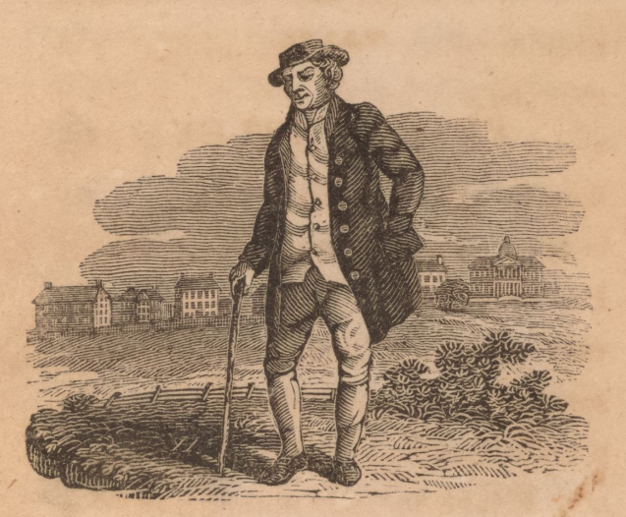

First edition. Boston: S. G. Goodrich, 1827, "HERE I am. My name is Peter Parley. I am an old man. I am very grey and lame. But I have seen a great many things, and had a great many adventures in my time, and I love to talk about them."

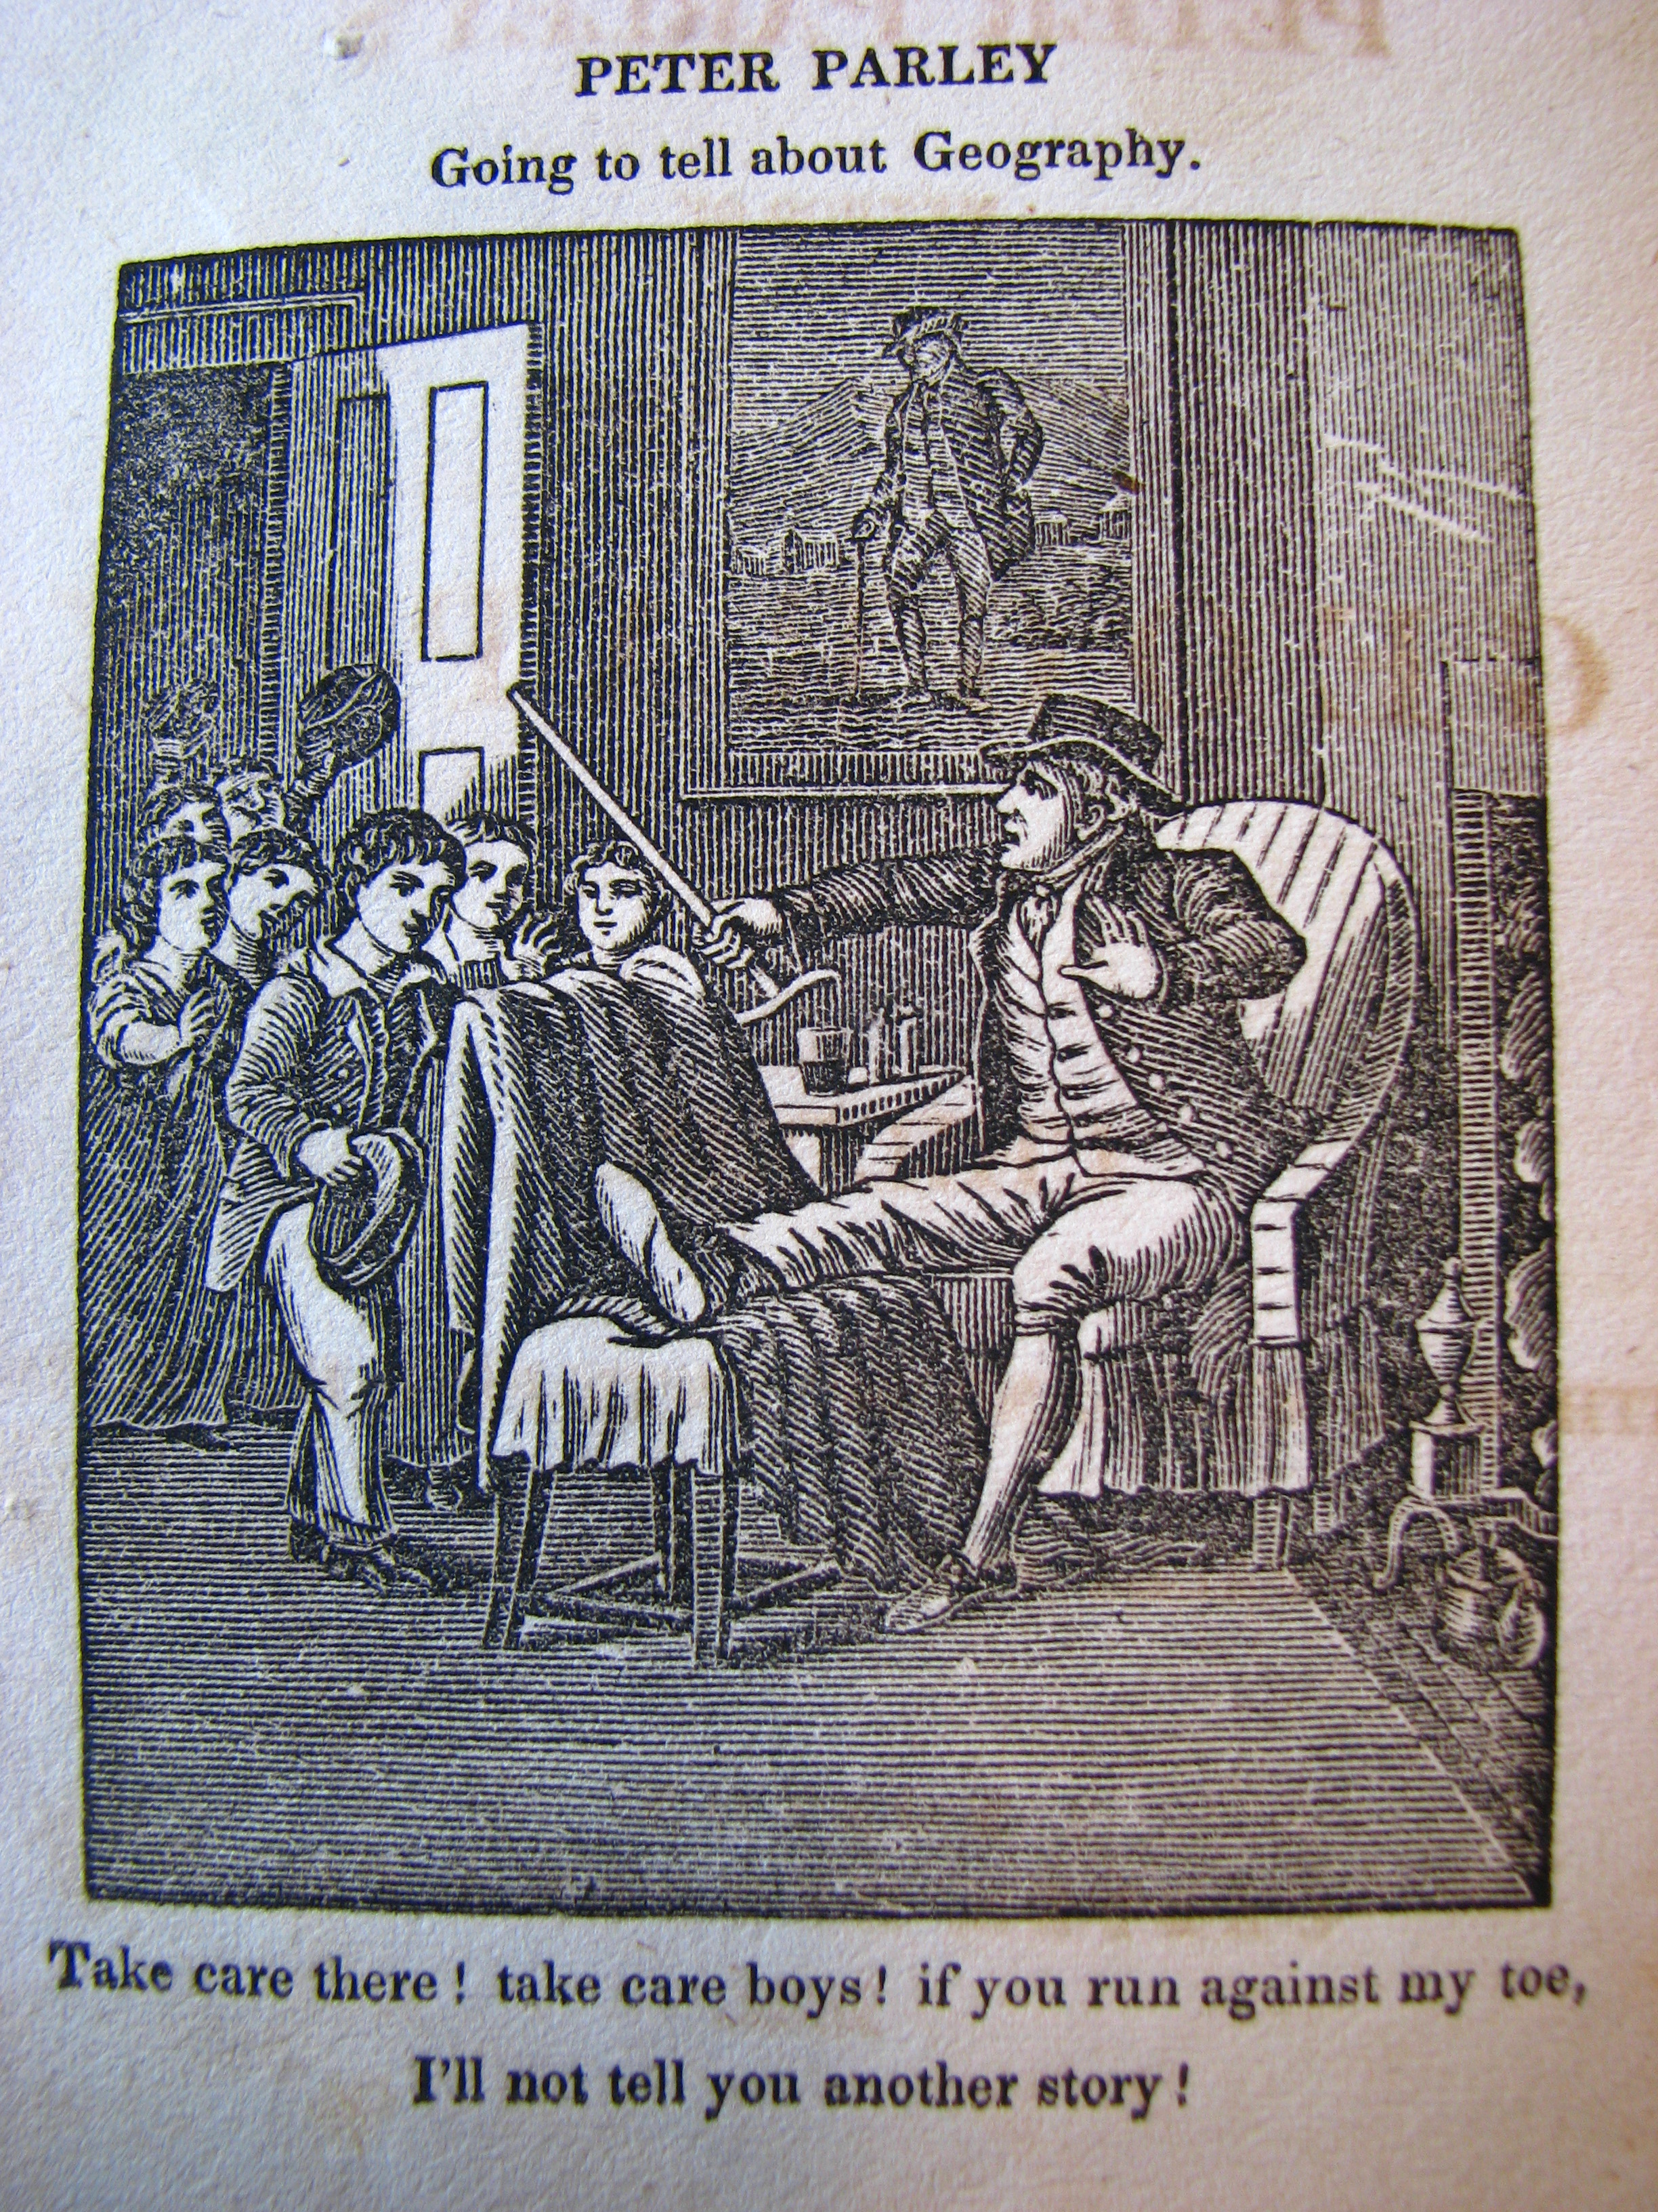

*Method of Telling about Geography*. First edition. Hartford: H. and F. J. Huntington, 1830. "Take care there! take care boys! if you run against my toes, I'll not tell you another story!" The word "gout" does not appear in this text. Note the original portrait of Parley on the wall! The preface to this text, signed P. P., deals with fictionality and genre. Same cuts are reused as in *Tales about America*. Especially the South America section which goes back to Woodbridge and perhaps Malte-Brun.

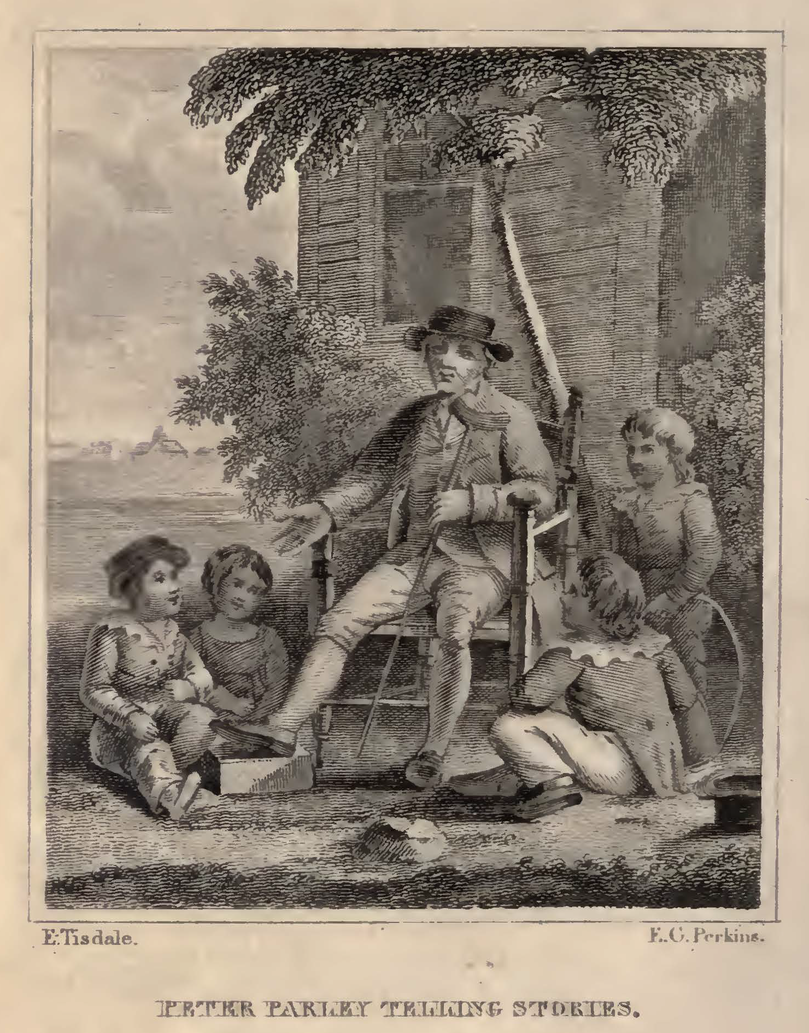

Fifth edition. Boston: Carter and Hendee, 1831. Signed by E[lkanah] Tisdale and F. G. Perkins. "HERE I am! My name is Peter Parley! I am an old man. I am very gray and lame. But I have seen a great many things, and had a great many adventures, and I love to talk about them." The Tisdale engraving also appears in the French edition (1832).

Disability can be read as addressing this problem by widening the gap between the situation of a tale's telling and the notional context in which it took place.

If character an effect of visual iconography. Goodrich footnotes the boy's exclamation that "he ain't Peter Parley."

[Show the pictures. Justify why I am NOT writing a reception history in the usual sense. Actually, the gout thing seems to not have been important. This disease would have had unfavorable connotations. Start Friday by using the Bourrier book; Parley as mix between C18 humor and C19 pathos.]

**Sources**

* Goodrich, Recollections (Goodrich)
* Pfliegl, "Parley as Brand"
* Brewer, Afterlife of Character
* Russell, Am. Journal on Parley's "avowed reuse"
* http://americanhistoricalstaffordshire.com/pottery/printed-designs/sources/state-house-boston
* http://americanhistoricalstaffordshire.com/pottery/printed-designs/patterns/state-house-boston-stubbs

## Practical Education at the Limit

Woodbridge, Gallaudet, Howe.

## Disabled Bodies, Enabled Attention?

The disabled pay attention in different ways. Close reading of Parley's magazine passage. Close reading of the Parley book. How norms for attention changed.

## TODO

* Complete outline
* Decide on sources
* Define what I mean by disability
* Contrast physical to mental impairment in Goodrich's world (the list of narrators with mental disability in modernist fiction is huge)
* Caspar Hauser in Parley's Magazine
* Key role of Alice Cogswell
* https://www.princeton.edu/~graphicarts/2008/10/index.html Track down Bowen's signature
* Who signed the "H" in the Parley print?

Make this more of a thesis. Does Crain talk about disability? What about the relation to illness? Cf. the literature on UTC, sentimentality. Also remark on the Continental (French, Prussian, Swiss) roots of both deaf and blind instruction AND progressive instruction writ large. As Samuel Howe puts it [Education of Blind in North American Review], the small(er) market comprised by blind institutions means a lack of impetus for innovation in the creation of apparatus and diagrams. The blind institutions also pioneer the use of students for apparatus creation.

*This section connects Goodrich's own disability and representational networks with the afterlives of the Parley character and its distributors.*

**Plan**

* [DONE] A trip to the South; footnoting the engravers
* [Written, work it in] importance of Crusoe
* The "Parley" name and brand
* Hannah More and Parley Porter as model; More's interest in Cogswell (166)
* Back to the material and textual sources
  + brother CA Goodrich: Columbian scenes (two publictions)
  + Woodbridge and Alice Cogswell and mental "machinery"
  + "Advances in Education"
* Strange case of the missing gout: never explicitly mentioned in the main sources; only in Recollections footnote
  + In fact, gout explicitly typed in Bible Gazetteer as harming one's relationship with God
* Connection to discourse of 19C sentimentality and sick children
* Physical disability, invalids and narrative "validity", mental disability, by accident vs. by birth, etc.

## Works Cited

Bourrier, Karen. *The Measure of Manliness: Disability and Masculinity in the Mid-Victorian Novel*. University of Michigan Press, 2015.

Goodrich, Samuel G. *Recollections of a Lifetime, or Men and Things I Have Seen: In a Series of Familiar Letters to a Friend, Historical, Biographical, Anecdotical, and Descriptive.* Edited by Richard C. Valentine et al., Miller, Orton and Mulligan, 1857.

1. The contrast is with the prevailing 18C tendency to find physical deformity comical.
2. *Tales about Africa* was the fifth of the Parley books and was first published in 1830.
3. The fact that such switching is how adult's conceptualize the pleasure of fiction should warn us about this approach. See Crain, Lesnik-Oberstein, Sanchez-Eppler, Berube.
4. See also the 1838 jug dispute in which Goodrich was referred to as "neighbor Parley."
5. Pictorial convention for views of the State House emphasized the rural nature of the Boston Common in the foreground See: http://web.cas.suffolk.edu/richman/SF1129/Images.htm. Parley is taking the place of the cows in these images!
6. Though the destruction of Goodrich's correspondence makes it difficult to prove, my sense is that Goodrich went back to his Hartford circle for the *Geography*. The embedded portrait might be Tisdale's way of asserting himself over Bowen? TODO: is there a Tisdale archive? Bowen?
7. There is a complicated story here. See Switaj and the James Joyce Online Notes, which are illuminating but incomplete. According to *The Bookseller* magazine, the Blackie and Sons edition was published sometime before 1901. Joyce does not have Parley in *Stephen Hero*, abandoned around 1904. *Portrait* was published in 1917.